Pre-Harvest Plan {mock-up example}
Prepared for the NC Foresters for Healthy Waters Program. June 20, 2021.
Landowner | Plan Writer
F4HW-Jordan West, LLC  c/o Pamela Pineytree, principle | Tom Gerow, Jr.  NC Registered Forester (RF) #1510  Certified Erosion, Sediment and Stormwater Inspector (CESSWI) #5544
17384 U.S. Highway 98-East | 1616 Mail Service Center
Sunnytown, FL 34987 | Raleigh, NC 27604
Phone: (980) 555-1234 | Phone: (919) 857-4824
Email: pineytree <at> email.com | Email: ncfs.water <at> ncagr.gov

Part 1. Tract and Owner Information
Tract Location: 1234 Big Woods Road. Hillytown, NC 27272. Piedmont County.
LAT 35.77, LON -79.05. Parcel ID No. 11-222-3333.
Tract Size: 100 acres.
Landowner Objectives
- Obtain funds from a large-scale sale of timber.
- Protect water quality in the streams and the nearby lake.
- Retain enough tall, full canopy trees, evenly dispersed across the property, to create an open woodlands appearance, and avoid having large clearcut areas. Some small open patches are acceptable.
- Provide habitat for game and non-game wildlife, especially turkey, rabbit, deer, songbirds and in-stream animals.

Current Condition / Tract Description
The 100-acres is comprised of multiple stands which are being treated as 1 management unit for this Pre Harvest Plan, as the entire tract will be harvested at the same time.
There are stand areas dominated by lobolly pine, ranging in age from 70 to 90 years, with some scattered shortleaf pine mixed in.
The remaining areas are mostly upland mixed hardwood species, with about 60% in oak species and the remainder consisting a mixture, including some hickory, sweetgum, maple and sycamore. The hardwood areas appear to be about the same age, as the pine.
However, the southernmost corner of the tract, south of stream #6, is younger in age and appears to have had a more recent harvest or disturbance, resulting in smaller and poorly-formed scattered timber. For this reason, and due to poor accessibility, this small area of 5-6 acres will not be harvested.

Management Recommendations
Conduct a harvest upon the entire tract at the same time. Selectively retain a mix of pine and hardwood species in the overstory, to create an open woodland stand appearance. Preference will be given to retain shortleaf pine and white oak in the overstory.
Promote natural regeneration of oaks and high-quality pine.
Snags will be retained if safe to do so, for wildlife habitat. After the harvest, the creation of snags may be evaluated, especially along the stream bottoms, if doing so will allow more sunlight to reach the ground and stimulate regeneration of desirable forest tree species and native shrubs/wildflowers.
Apply prescribed fire in a periodic cycle ranging from every 4 to 6 years, to maintain the open understory, stimulate oak regeneration, as well as native grasses and wildflowers for pollinators.
If needed, control invasive/exotic plants with herbicide and/or other methods.

Timeline
July 2021: Complete Preharvest Plan.
Aug./Sept. 2021: Mark Timber Sale Area, including SMZ/Buffer Rule zones.
Oct./Nov. 2021: Send out Timber Bid Solicitation.
Jan. 2022: Execute Timber Sale Contract.
Spring/Summer 2022: Implement the Harvest.
It is recommended that the timber sale contract allow for an extension of time to complete the harvest, to avoid logging during wet soil conditions. See Part 3 of this Plan for details.

Part 2. Review of At-Risk Animals and Critical Habitat
The Foresters for Healthy Waters Program is focused on protecting rare and at-risk aquatic animals, and their habitat.
The following at-risk animals are potentially affected by activities on this tract:
- Neuse River Waterdog (a large salamander).
- Yellow Lance (a freshwater mussel).
- Atlantic Pigtoe (a freshwater mussel).

For this tract, a major stream nearby is designated as Critical Habitat for the Yellow Lance, a freshwater mussel that is a federally-listed Threatened species. See maps below.

Extra attention is needed to keep sedimentation from entering streams, prevent and promptly control soil erosion, and use care along the stream corridor to minimize disturbance.
- Stream crossings and other impacts to streams should be avoided.

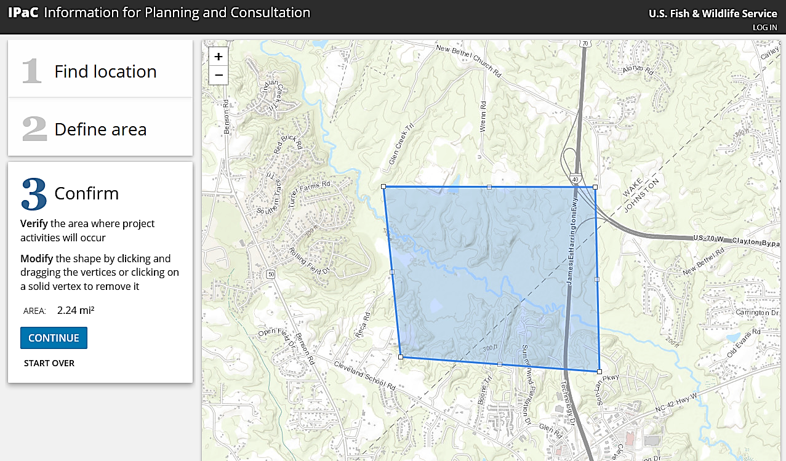
At-risk animals were identified from the polygon drawn on the map on the USF&WS “IPaC” website tool: https://ecos.fws.gov/ipac/, accessed 5/06/2021.

Aerial map showing Swift Creek (in red line) designated as Critical Habitat for the Yellow Lance mussel.
Your tract is located approximately at the X on the map, less than ½-mile from Swift Creek.
Map obtained from USF&WS Critical Habitat Map Viewer at https://ecos.fws.gov/ecp/, accessed 5/03/2021.

Part 3. Soils and Associated BMP Measures
Reference the soils map that also includes a detailed soils report, both provided with this plan.
- Nearly 40% of the harvest area is rated as having “severe” erosion risk on roads/skid trails.
- Nearly 90% of the harvest area is rated as having “severe” rutting hazard.
Erosion Risk: This is the area mapped as the “GkE” soil mapping unit, the Georgeville-Badin Complex, with 15% to 30% slopes, and includes most of the interior of the northern-half of the tract.
Rutting Hazard: Multiple soil map units on this tract have a severe rutting hazard:
ChA: Chewacla and Wehadkee soils (loam), 0% to 2% slope (along a major stream bottoms)
GaB: Georgeville silt loam, 2% to 6% slope
GaC: Georgeville silt loam, 6% to 10% slope
GkE: Georgeville-Badin Complex (silty loam), 15% to 30% slopes
NaC: Nanford-Badin complex (silty loam), 6% to 10% slope

As result of these widespread severe ratings for both soil characteristics, the following BMP measures will need to be implemented to control accelerated erosion, manage rutting, and minimize sedimentation:
{ list what BMPs you think are most important…below are some possible examples }
- Harvesting must occur during a dry period. This will ensure the soil is strong enough to carry the logging tractors and minimize rutting. Using a tracked-mounted tree cutter and skidders with dual-tires may be needed to spread-out the weight of the machines and reduce rutting.
- No logging roads will be constructed on the tract. This will minimize soil disturbance and exposure.
- NOTE: This means the logger will need to skid (drag) timber for a longer distance, and that will likely increase his costs, thus requiring a higher logging rate to be paid. That increased logging cost may result in you receiving a lower stumpage value for the timber.
- Skid trails will be installed immediately atop of the ground surface, not excavated or bladed-in. This will minimize soil disturbance and exposure.
- As soon as logging starts, and for the duration of the job, leftover logging debris (limbs, branches, tree tops) will be collected and spread-out atop of the skid trails as much as possible. This debris will cushion the soil, help to support the tractors, and immediately cover exposed soil. Priority will be focused on covering sloping sections of skid trails.

Part 4. Streamside Management Zones / Riparian Buffers
There are six streams on the tract which require a protective Streamside Management Zone (SMZ), and three of them also require an additional Riparian Buffer Rule zone in accordance with the Neuse River or Tar-Pamlico River Riparian Buffer Rule. The Forest Harvesting Requirements for the Riparian Buffer Rule are explained in the North Carolina Forest Service’s Forestry Leaflet #WQ-10, available at: www.ncforestservice.gov/publications/Forestry%20Leaflets/WQ10.pdf.

The map below shows the streams on a topographic contour map, numbered from north-to-south.
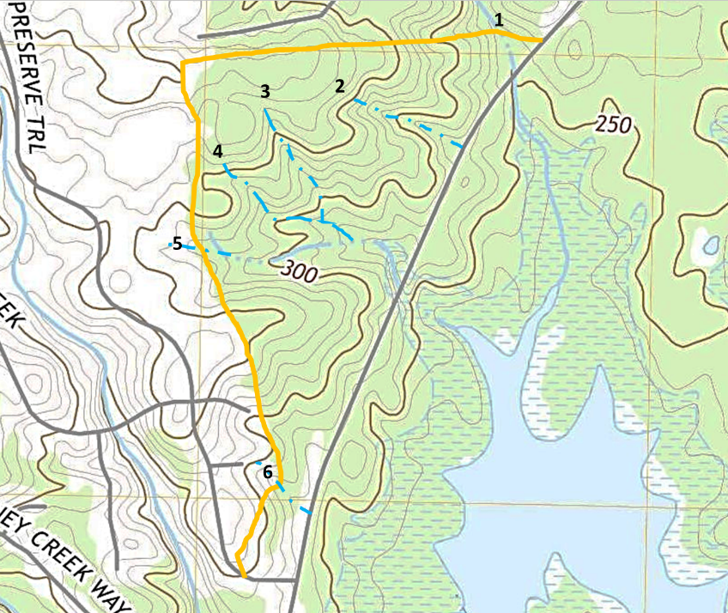
Excerpt from the USGS 2019 “Farrington” 1:24000 topographic map quad. Not to scale.
Orange line is tract boundary. Blue lines numbered 1-6 represent the approximate locations of Intermittent or Perennial streams, based on verification from a site examination. Many Ephemeral streams (dry hollows) also occur on the tract, along with some old erosion gullies.
Stream # | Est. Length on Tract (feet) | Reference Source | Required Protection
1 | 450 | USGS topo map and Soil Survey | SMZ + _______ Buffer Rule
2 | 1,000 | Found on site | SMZ
3 | 950 | Found on site | SMZ
4 | 1,000 | Soil Survey | SMZ + _______ Buffer Rule
5 | 1,800 | USGS topo map and Soil Survey | SMZ + _______ Buffer Rule
6 | 380 | Found on site | SMZ

- To be eligible to receive cost-share assistance in the Foresters for Healthy Waters Program, each SMZ must be a minimum of 50-feet wide (on each side of the stream).

In addition, this Program recommends that no timber be harvested from the entire SMZ. However, some allowances for timber removal are provided, as long as additional protective measures are described and put into place to assure protection of water quality.
Below is an outline of how timber harvesting will be managed along each stream.
For all 6 Streams:
Layout: The outer edge of each SMZ/Buffer Rule zone will be flagged with blue flagging tape.
Timber Marking: Trees to be harvested within the SMZ/Buffer Rule zone will have a large “X” painted on the tree trunk with blue spray paint.

Stream 1: SMZ + Buffer Rule
Type of Timber to Harvest: Maximize timber harvesting in accordance with the ________ River Riparian Buffer Rule. Pine trees must be at least 14” DBH to harvest; Non-Pine trees must be at least 16” DBH to harvest.
Minimize Damage: Trees will be harvested and felled outside of the SMZ.
Provide Stream Shade: Trees immediately along the streambank edge will remain intact.
Ephemeral Transition Area: This stream crosses through the tract boundary on both ends, so there is no ephemeral stream area to include.

Stream 2: SMZ
Type of Timber to Harvest: Only large, high value pine trees will be harvested, with diameter limit to be determined at time of timber cruise. All hardwood trees will remain intact. It is expected that only about 20% of the SMZ trees will be harvested.
Minimize Damage: Trees will be harvested and felled outside of the SMZ.
Provide Stream Shade: Trees immediately along the streambank edge will remain intact.
Ephemeral Transition Area: This stream ends within the harvest area. The SMZ will be wrapped around the head-end of the stream to include the ephemeral area.

Stream 3: SMZ
Type of Timber to Harvest: Only large, high value pine and oak trees will be harvested, with diameter limit to be determined at time of timber cruise. Most of the pine to be harvested is located along the lower reach of this stream. Some high-quality oak will be harvested. It is expected that about 30% to 50% of the SMZ trees will be harvested.
Minimize Damage: Trees will be harvested and felled outside of the SMZ
Provide Stream Shade: Trees immediately along the streambank edge will remain intact.
Ephemeral Transition Area: This stream ends within the harvest area. The SMZ will be wrapped around the head-end of the stream to include the ephemeral area.

Stream 4: SMZ + Buffer Rule
Type of Timber to Harvest: Harvest timber in accordance to the _______ River Riparian Buffer Rule, but leave some timber standing in Zone 2 (do not clearcut from 30ft to 50ft mark). Pine trees must be at least 14” DBH to harvest; Non-Pine trees must be at least 16” DBH to harvest.
Minimize Damage: Trees will be harvested and felled outside of the SMZ
Provide Stream Shade: Trees immediately along the streambank edge will remain intact.
Ephemeral Transition Area: This stream ends within the harvest area. The SMZ will be wrapped around the head-end of the stream to include the ephemeral area.

Stream 5: SMZ + Buffer Rule
Type of Timber to Harvest: Only approximately 10 to 12 high-quality oak trees will be harvested from along the outer edge of this entire SMZ/Buffer Rule zone. All remaining timber will remain un-disturbed.
Minimize Damage: Trees will be harvested and felled outside of the SMZ
Provide Stream Shade: Nearly all trees in the interior of the SMZ/Buffer Rule zone, and all trees along the stream channel, will remain intact.
Ephemeral Transition Area: There are 2 deep ephemeral streams that run down-slope into this SMZ, both along the northern edge of the SMZ. This SMZ will be expanded at those 2 intersections to include the ephemeral transition area.

Stream 6: SMZ
Type of Timber to Harvest: The entire 50-foot SMZ will remain un-disturbed. No trees will be harvested due to their small size, inferior timber quality, and the rugged terrain with limited accessibility and close proximity to neighboring homes. The area south of Stream 6 will also remain un-disturbed with no trees harvested, for these same reasons.
Minimize Damage: n/a
Provide Stream Shade: All trees in the SMZ will remain intact.
Ephemeral Transition Area: This stream crosses through the tract boundary on both ends, so there is no ephemeral stream area to include.

Part 5. Stream Crossings
During the site exam, no existing stream crossings were observed. There will need to be 2 new stream crossings installed to provide access for this timber harvest. The approximate crossing locations are noted on the aerial photo map below.
Aerial photo map. Not to scale. Blue lines represent estimated locations of intermittent or perennial streams. Orange & yellow circle-X marks are approximate stream crossing locations to be installed.
From the NC Forest Preharvest Planning Tool, www.ncforestservice.gov/water_quality/fppt.htm, 5/04/2021.

Below is an outline of how each crossing will be managed, from north to south.
Crossing #1 (Stream 1):
Justification: This crossing is needed because access is limited on the north end due to the property boundary line, which is adjacent to an underground natural gas pipeline. Access upon the pipeline corridor is restricted. Also, the tract of timber is elevated ~20 feet above Big Woods Road at this location, limiting the ability to access the pine timber from a roadside deck, on the north side of the stream. Due to the dense spacing and high quality of the pine timber in this corner of the tract, foregoing harvest is not recommended, in order to maximize timber sale revenue and maintain good forest health conditions.
Crossing Type: Temporary / Skid Trail.
Method: Bridgemats.
BMP Measures:
- Location will be flagged prior to installation.
- At least 3 bridgemats will be used, in order to establish a full-width platform for the skidders to drive across and not leave a gap for debris and soil to drop down in the stream.
- Bridgemats must be tightly butted together to minimize gaps in between.
- Logging slash/debris will be applied to the exposed soil on the skid trail crossing approachways and maintained to prevent erosion and provide groundcover stabilization.
- Large log stringers (“curb logs”) will be laid down along each side of the bridgemat crossing platform to help catch debris from rolling-off the edges and down into the stream.
- If needed, “bumper trees” will be left standing on the approachway entry to each side of the crossing, to help funnel the drag of timber and minimize soil and debris from being dragged into the stream.
- After completion, logging debris that may have been deposited into the stream will be removed by hand to prevent stream flow obstruction.
- The stream banks will be stabilized as needed after removal of the bridgemats.

Crossing #2 (Stream 5):
Justification: Access from the back-side (west side) of this tract is not possible due to an existing golf course community development of homes. Also, the terrain on the tract does not allow for easy access off of Big Woods Road, therefore only 1 location was found suitable to establish a log deck and turnaround location for log trucks to navigate off the public highway. The log deck will be on the north side of this stream in the pine stand area, and therefore will require a stream crossing to access timber on the south side of this stream, which crosses through the entire tract.
EXAMPLE 1:
Crossing Type: Temporary / Skid Trail.
Method: Bridgemats
BMP Measures: Implement same BMP measures outlined for crossing #1.

EXAMPLE 2: If a culvert or ford is elected to be installed, explain the reason why.
A culvert will be installed to provide skid trail logging access, and future access after the harvest for the landowner to operate an off-road vehicle (UTV), to facilitate prescribed burning and patrolling the property.
Crossing Type: Permanent / Skid Trail.
Method: Culvert.
Culvert Specs: Corrugated galvanized metal round culvert, 48 inches diameter. Size is based on estimating the watershed drainage area to be 70 acres, using the USGS StreamStats tool, and the NCFS culvert sizing online calculator worksheet.
BMP Measures:
- In addition to the key BMPs listed below, reference the NC Forestry BMP Manual (Ch.5, Part 3).
- Install the culvert with the bottom 4 to 6-inches buried into the streambed, so that aquatic life can more easily navigate through the pipe.
- Apply and pack down at least 24 inches of backfill soil atop the culvert.
- Promptly apply seed/straw groundcover on backfill. Coconut fiber matting may be needed.
- Reinforce the headwalls firmly with riprap.
- Install a dip within each approachway to allow floodwater to flow up & around the culvert.

Part 6. Forest Operations
Access Entrance
Large gravel-stone (“surge rock / ballast stone”) will be applied to the access road entry onto Big Woods Road, for a distance of 100 feet in from the public highway. A temporary culvert pipe or bridgemat panels will need to be installed in the highway ditch so log trucks can enter/exit the tract. Do not plug the highway ditch.

Roads
There are no existing roads upon the tract, although an old pathway was barely visible coming off from Big Woods Road about half-way down the property edge. Due to the terrain, the widespread “severe” soil hazard ratings, and the type of timber harvest, no new roads will be constructed on this tract. NOTE: This means the logger will need to skid (drag) timber for a longer distance, and that will likely increase his costs, thus requiring a higher logging rate to be paid. That increased logging cost may result in you receiving a lower stumpage value for the timber.

Log Deck
One log deck will be established. The size may need to larger than normal so that log truck tractor trailers can safely exit Big Woods Road and get turned around off the public highway.
The log deck location will be at least 50 feet from the edge of the nearest SMZ/Buffer Rule zone.
Logging debris will be applied to bare soil on the log deck to provide groundcover, where the skidders operate into and out of the log deck area.
After Completion: Seed & straw will be applied on the log deck and truck turnaround. Debris piles should be less than head-high, and as needed debris will be scattered on the deck and/or skid trails.

Skid Trails
It is expected that all primary skid trails will be located at least 50 feet from the edge of the SMZ, with the exception of the harvest area between Stream 3 and Stream 4, which are close together. In that location, rolling dips will be installed to control runoff and the entire length of the skid trail between those 2 streams will be covered in logging slash.
On all other primary skid trails, logging slash will be applied on the sloping sections for erosion control.

Fluids/Chemicals
Re-fueling and equipment maintenance will occur in the log deck area.
Any petroleum that discharges onto the soil will be excavated by hand and removed off-site.

Triggers to Stop Logging
To maximize protection of the at-risk aquatic animals and their habitat, and because of the “severe” ratings of the soils on this tract, logging will cease if any of the following occurs, and will not resume until corrective actions are taken or the site conditions improve:
- Sedimentation, petroleum, or other chemical pollution enters an intermittent or perennial stream.
- Soil rutting occurs that is approximately knee-deep or deeper, for a distance of 100 feet or more, on a primary skid trail or in the woods.
- The streams are overflowing out of their banks from heavy rainfall.
- Turbidity is observed in the lake that is located downstream from this harvest, and it appears to be coming from the harvest tract.
- Logging equipment is found to have operated within the stream channel.

Part 7. Rules Awareness
There are several rule requirements to assure protection of water quality and aquatic habitat.
Below is a summary of notable water quality rules that apply to this tract.
Federal Clean Water Act, Section 404
If a stream crossing is installed in an Intermittent or Perennial stream; or a road or skid trail is constructed in a wetland, the federal Clean Water Act includes 15 required BMPs to minimize the discharge of dredged or fill material into a water of the U.S. Those 15 requirements are available at this website link [see items 6(i) through 6(xv)]:
https://ecfr.federalregister.gov/current/title-33/chapter-II/part-323/section-323.4
One of those 15 required BMPs includes the following provision tied to T&E species [item (ix)]:
“The discharge shall not take, or jeopardize the continued existence of, a threatened or endangered species as defined under the Endangered Species Act, or adversely modify or destroy the critical habitat of such species.”

State of North Carolina: FPGs
All forestry-related, land-disturbing activities are required to comply with the 9 standards prescribed in the statewide rules called the Forest Practices Guidelines Related to Water Quality (FPGs). The FPGs apply to any Intermittent Stream and any Perennial Stream, regardless if that stream appears on a map, or not. The FPGs are outlined in N.C. Forest Service Forestry Leaflet #WQ-1: https://www.ncforestservice.gov/publications/Forestry%20Leaflets/WQ01.pdf

State of North Carolina: DWR River Basin Riparian Buffer Rules [where applicable]
In the Neuse River basin and Tar-Pamlico River basin, there are additional requirements to protect and maintain riparian stream buffers along certain designated mapped streams. These ‘Riparian Buffer Rules’ include special Forest Harvesting Requirements that limit forestry practices and timber harvest within the 50-foot wide required Buffer Rule Zone. The Forest Harvest Requirements are explained in N.C. Forest Service Forestry Leaflet #WQ-10, available from their website: https://www.ncforestservice.gov/publications/Forestry%20Leaflets/WQ10.pdf

To be eligible to selectively harvest timber from Zone 1 of the Buffer Rule, the tract must either:
A) Be enrolled in the county’s Present-Use Value (PUV) Program for Forestry; or,
B) Have a forest management plan that is prepared or approved by a Registered Forester.

For questions about the Riparian Buffer Rules, contact a Buffer Rule Specialist of the Water Quality Regional Operations, in the Raleigh Regional Office for the NCDEQ-Division of Water Resources: 919-791-4200. https://deq.nc.gov/contact/regional-offices/raleigh.

Federal Endangered Species Act: Section 4(d) Rule
[to be determined -- see Appendix B of the Program Handbook]

Part 8. Agency Contacts
Notify the N.C. Forest Service (NCFS) County Forest Ranger Office within 3 days of starting the timber harvest activity.
They will examine the site during the logging to monitor for compliance with the FPGs and observe any harvesting within the Riparian Buffer Rule zone. If the NCFS observes a potential Riparian Buffer Rule violation, then it will notify the N.C. Division of Water Resources (DWR), so that DWR can inspect the site, determine compliance and if needed, require corrective action and/or buffer restoration.
____________ County Forest Ranger: first name last name
Office Ph: (999) 555-4444. Email: first.last @ncagr.gov

Additional References Included
1. Aerial Photo Map with Streams
2. Soil Survey Manuscript Map with Streams
3. Soil Detail Report with Web-Soil Map

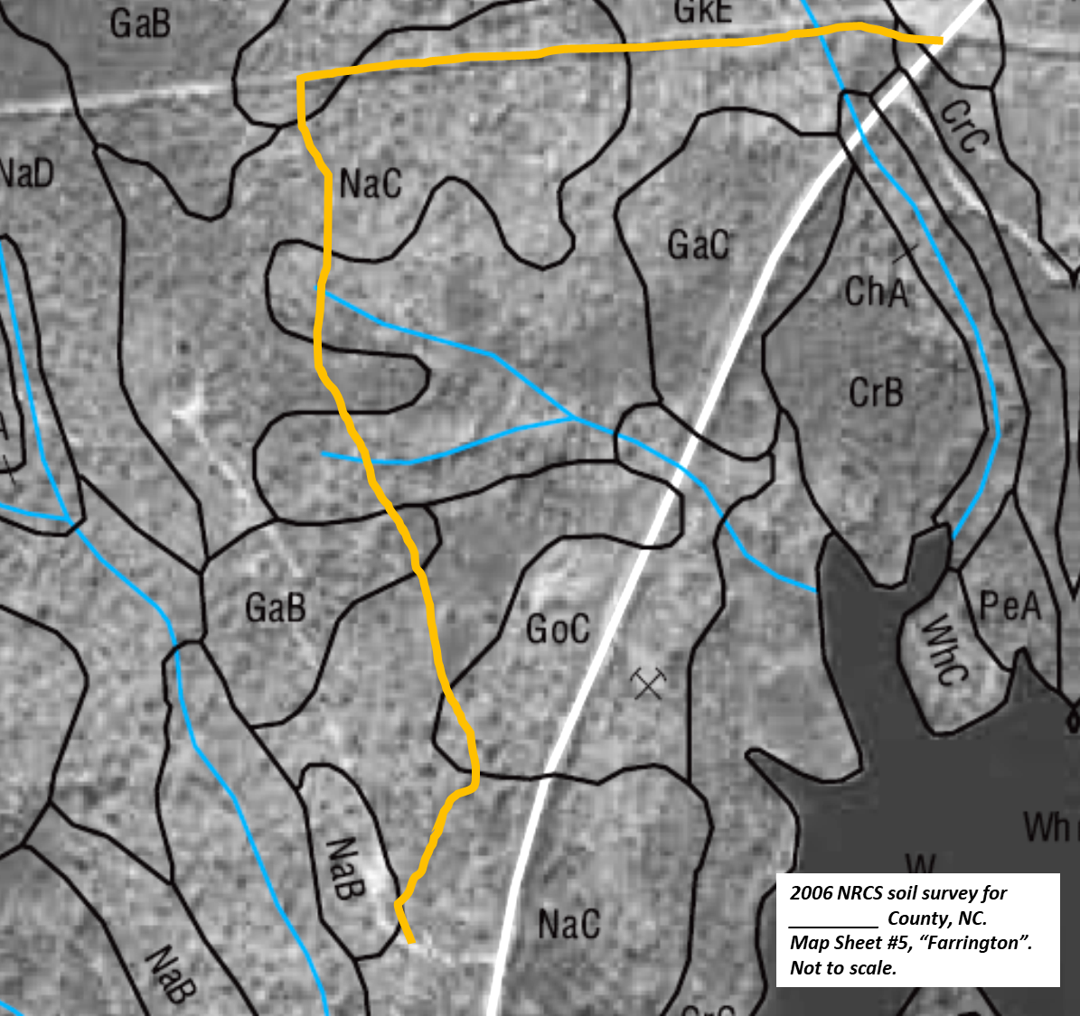
Excerpt from the soil survey manuscript. Not to scale.
Orange line is tract boundary, blue lines are streams depicted by the soil survey manuscript.

