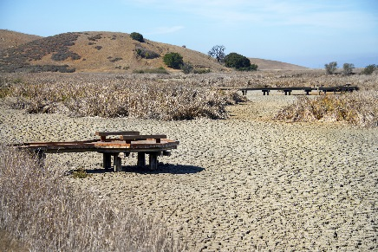

Join Us for a Webinar

The Effects of Drought on Recreation and Wilderness
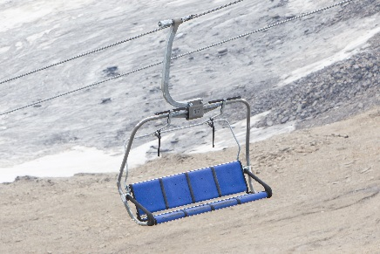
March 22, 2017, 2:00pm to 3:30pm Eastern

Please join the Office of Sustainability and Climate for a webinar exploring how researchers, resource managers, and industry professionals are assessing and addressing the impacts of drought on recreation and Wilderness opportunities and experiences.
Agenda
Moderator - Matt Arnn, (US Forest Service, Chief Landscape Architect)
2:00 | Introduction – Sue Spear, US Forest Service, Director of Wilderness and Wild and Scenic Rivers
2:05 | Assessing Vulnerability to Drought of Recreation in National Forests - Michael Hand, Research Forester, Rocky Mountain Research Station
2:20 | How the Spatial and Temporal Availability of Freshwater Affects Outdoor Recreation in the High Deserts of the Intermountain West, USA - Jordan Smith, Director, Institute of Outdoor Recreation and Tourism, Utah State University
2:35 | Recreation Impacts to Forest Service Wilderness Areas: the Effects of Urbanization and Drought (2010-2060) – Rebecca Rasch, US Forest Service, Region 1 Social Scientist
2:45 | Questions and Answers
2:55 | Drought and the Ski Industry – Scott Fitzwilliams, Forest Supervisor, White River NF; Rick Cables (Vice President for Natural Resources and Conservation – Vail Resorts)
3:05 | Adapting Recreation to a Changing Climate – Nancy Brunswick, US Forest Service, Region 4 Regional Landscape Architect
3:15 | Questions and Answers
3:25 | Concluding Remarks - Joe Meade ( US Forest Service, Director of Recreation, Heritage, and Volunteer Services)
3:30 | Adjourn

Connection Information
Webinar information: http://climatewebinars.net/webinars/drought-recreation-wilderness Audio Conference Line: 1-877-369-5243; Access Code: 0353212#
WO Meeting Room: Civilian Conservation Corps (PNW04)
Questions? Contact Lois Ziemann, lziemann@fs.fed.us

Speaker Information

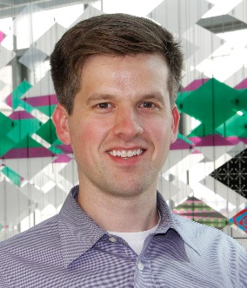 | Michael Hand is a Research Economist with the USDA Forest Service, Rocky Mountain Research Station in Missoula, MT, and a Fellow with the Office of Evaluation Sciences in the General Services Administration in Washington, DC. His research focuses on the benefits people derive from forests and the natural environment, economic vulnerability and resilience to climate-related forest changes, the economics of wildfire suppression, and risk perception and preferences of public managers. He received a PhD and Master’s degree in Economics from the University of New Mexico, and his undergraduate degree from the University of Minnesota.
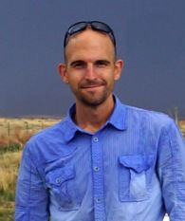 | Jordan Smith is the Director of the Institute of Outdoor Recreation and Tourism and an Assistant Professor in the Department of Environment and Society at Utah State University. His research examines how humans make behavioral and planning adaptations in response to rapidly changing environmental conditions. He uses stated preference experiments, geospatial modeling and immersive virtual environments to understand contingent behaviors and preferences. Jordan earned his Ph.D. in Parks, Recreation and Tourism Management with minors in both Geospatial Information Science and Technology and Sociology from NC State. Off-campus, Jordan is an active cyclist and motorcyclist enthusiast.
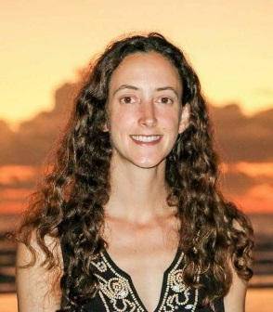 | Rebecca Rasch, PhD, is a Presidential Management Fellow, US Forest Service Region 1 Social Scientist, and research fellow with the Aldo Leopold Wilderness Research Institute. Rebecca has also served as the Senior Project Manager and Statistical Consultant for the Social Science Research Council, and has worked for several non-profit organizations focused on sustainable development and environmental policy. Rebecca earned a BA in American Studies from Wesleyan University, a MBA from the University of Virginia, and a PhD in Sociology and certificate in Demography from The Graduate Center at the City University of New York. Her research specialization areas include urbanization, spatial and environmental demography, and economic sociology.
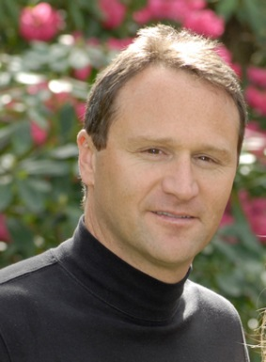 | Scott Fitzwilliams is the Forest Supervisor of the White River NF in Colorado. He has also served as the Deputy Forest Supervisor on the Willamette NF, Staff Officer for Recreation, Wilderness Lands and Minerals on the Tongass NF, District Ranger on the Little Missouri NG, and Public Affairs Officer on the Bridger-Teton NF. Scott has served as the lead for the Forest Service National Climate Change Communication team, Alaska Wilderness Advisory Group and the Interagency Grizzly Bear Committee. In 2010, Scott was selected as an Aspen Institute Environment Forum Scholar. Throughout his career, Scott has specialized in the human dimensions of natural resource management focusing on public involvement, collaboration and policy development.
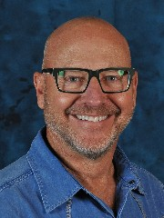 | Rick Cables is Vice President for Natural Resources and Conservation for Vail Resorts, which includes ski resorts in the U.S., British Columbia, and Australia. Rick oversees Vail Resort’s industry-leading conservation and sustainability efforts where his work is primarily accomplished through longstanding partnerships with the U.S. Forest Service, state wildlife agencies, and non-profit conservation organizations. Before joining Vail Resorts, Rick was director of Colorado Parks and Wildlife, whose 900 employees manage nearly $4 billion in economic activity each year. Rick’s first career – of 35 years – was with the U.S. Forest Service, culminating is 10 years as the Regional Forester for the Rocky Mountain Region. His vision and energy led to a nationally significant partnership with municipal water providers and recreation interests.
 | Nancy Brunswick is the Regional Landscape Architect and Developed Recreation Program Manager for the Intermountain Region of the U.S. Forest Service. Nancy has been part the Intermountain Adaptation Partners Assessment Team, whose purpose is to prepare for climate change through science-management collaboration. As part of her assessment work, Nancy helped identify vulnerabilities and management strategies for recreation and scenic resources related to climate change. The Draft Intermountain Adaptation Partnership: Vulnerability Assessment Summaries is available here.

